# [Mariska Hargitay Says The First New “Law & Order SVU” is Ripped from the Headlines, Called “Remember Me in Quarantine”](https://www.showbiz411.com/2020/09/12/mariska-hargitay-says-the-first-new-law-order-svu-is-ripped-from-the-headlines-called-remember-me-in-quarantine)

* ■[Celebrity](https://www.showbiz411.com/category/celebrity)
* ■[Television](https://www.showbiz411.com/category/tv)

by [Roger Friedman](https://www.showbiz411.com/author/roger) - September 12, 2020 12:05 am

[*0*](https://www.showbiz411.com/2020/09/12/mariska-hargitay-says-the-first-new-law-order-svu-is-ripped-from-the-headlines-called-remember-me-in-quarantine#respond) *70827*

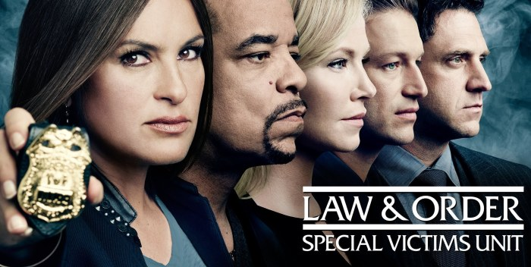

The 22nd season of “Law & Order SUV” starts shooting on Monday. Star Mariska Hargitay says on Instagram: “the band is back together!”

In the grand tradition of all “Law & Order,” the script by Warren Leight and Julie Martin is ripped from the headlines. It’s called “Remember Me in Quarantine.” So the show is not avoiding the events of the last six months. I knew they’d hit it head on!

Will everyone be wearing masks? Let’s hope not. We’ll cut them some slack.

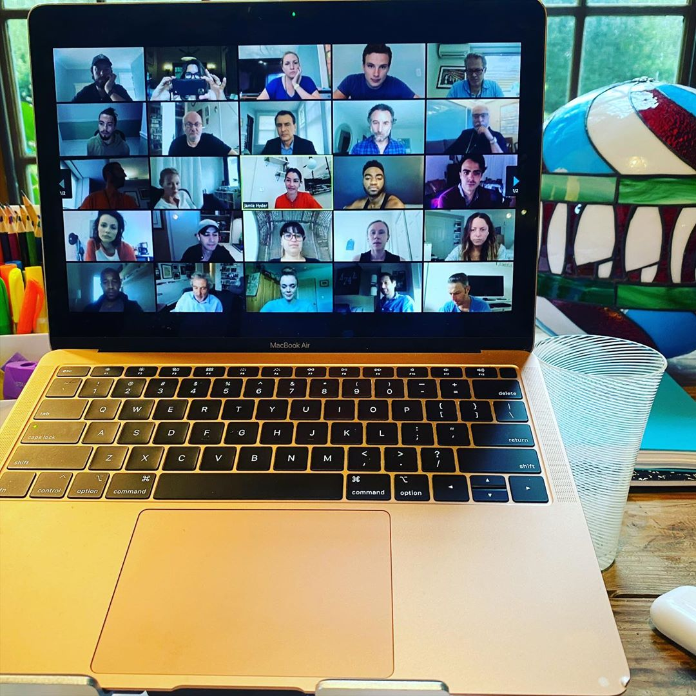

**148.742 curtidas**

* 

## [**therealmariskahargitay**](https://www.instagram.com/therealmariskahargitay/)

## Verificado

It’s official!  
The bands back together! We had our first read thru today. [#zoom](https://www.instagram.com/explore/tags/zoom/) Remember me in quarantine.[#SVU22](https://www.instagram.com/explore/tags/svu22/) We start shooting Monday. 2️⃣2️⃣

1 sem

* + 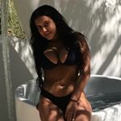

### [**kkaltabanis**](https://www.instagram.com/kkaltabanis/)

URGHHH [@potafountotos](https://www.instagram.com/potafountotos/)

[4 d](https://www.instagram.com/p/CFBZ1ciHY2c/c/17863296707077926/)**1 curtidaResponder**

* + - **Ver respostas (1)**
  + 

### [**jessiemac_718**](https://www.instagram.com/jessiemac_718/)

I could literally cry from joy to hear that filming has finally started. I miss this show so much. It gives me life. ❤️🙏👏

[3 d](https://www.instagram.com/p/CFBZ1ciHY2c/c/17889743902655868/)**Responder**

* + 

### [**catie_elmore**](https://www.instagram.com/catie_elmore/)

[@hannahbutler720](https://www.instagram.com/hannahbutler720/)

[3 d](https://www.instagram.com/p/CFBZ1ciHY2c/c/17857838852184078/)**1 curtidaResponder**

* + 

### [**kenzie.paterson**](https://www.instagram.com/kenzie.paterson/)

[@zavala70](https://www.instagram.com/zavala70/) yesssssss

[3 d](https://www.instagram.com/p/CFBZ1ciHY2c/c/17882420629773786/)**1 curtidaResponder**

* + 

### [**sara_ann.e**](https://www.instagram.com/sara_ann.e/)

FINALLY

[3 d](https://www.instagram.com/p/CFBZ1ciHY2c/c/17881003576752379/)**Responder**

* + 

### [**sebrinalovebridalsllc**](https://www.instagram.com/sebrinalovebridalsllc/)

Soooooo excited!!!👏👏👏👏👏👏👏👏👏👏👏💞💕💖💞💖💕💖💞💖💕💖💞

[3 d](https://www.instagram.com/p/CFBZ1ciHY2c/c/17843459282383578/)**Responder**

* + 

### [**cynmarie_154**](https://www.instagram.com/cynmarie_154/)

Is Olivia gonna have a love story this season 🤞🏽🤞🏽

[3 d](https://www.instagram.com/p/CFBZ1ciHY2c/c/17859184538162238/)**Responder**

* + 

### [**hannah.thousand**](https://www.instagram.com/hannah.thousand/)

YESSSSSSSSSSSSSSSSSSSS, omg I've literally binge watched episode after episode... I've sat on my couch for at lease 7 hours watching this...

[3 d](https://www.instagram.com/p/CFBZ1ciHY2c/c/18102169540171920/)**Responder**

* + 

### [**finney6869**](https://www.instagram.com/finney6869/)

My favorite show even without Elliot. Stabler but it would be great to have him and Dann Florek back

[2 d](https://www.instagram.com/p/CFBZ1ciHY2c/c/17853025676282326/)**Responder**

* + 

### [**finney6869**](https://www.instagram.com/finney6869/)

Dick Wolf really knows how to pick winners

[2 d](https://www.instagram.com/p/CFBZ1ciHY2c/c/17966914798323767/)**1 curtidaResponder**

* + 

### [**italianmama5454**](https://www.instagram.com/italianmama5454/)

🙌❤️

[1 d](https://www.instagram.com/p/CFBZ1ciHY2c/c/17891797660625896/)**Responder**

* + 

### [**sophiavonstardust**](https://www.instagram.com/sophiavonstardust/)

😍😍😍 [@redhead_rogue_leader](https://www.instagram.com/redhead_rogue_leader/)

[7 h](https://www.instagram.com/p/CFBZ1ciHY2c/c/17871285949963030/)**Responder**

[12 DE SETEMBRO](https://www.instagram.com/p/CFBZ1ciHY2c/)

[Entrar](https://www.instagram.com/accounts/login/?next=%2Fp%2FCFBZ1ciHY2c%2F&source=post_comment_input) para curtir ou comentar.

Instagram

Pesquisar

**Entrar no Instagram**

### **Share this:**